Upload Yaml file to generate test cases

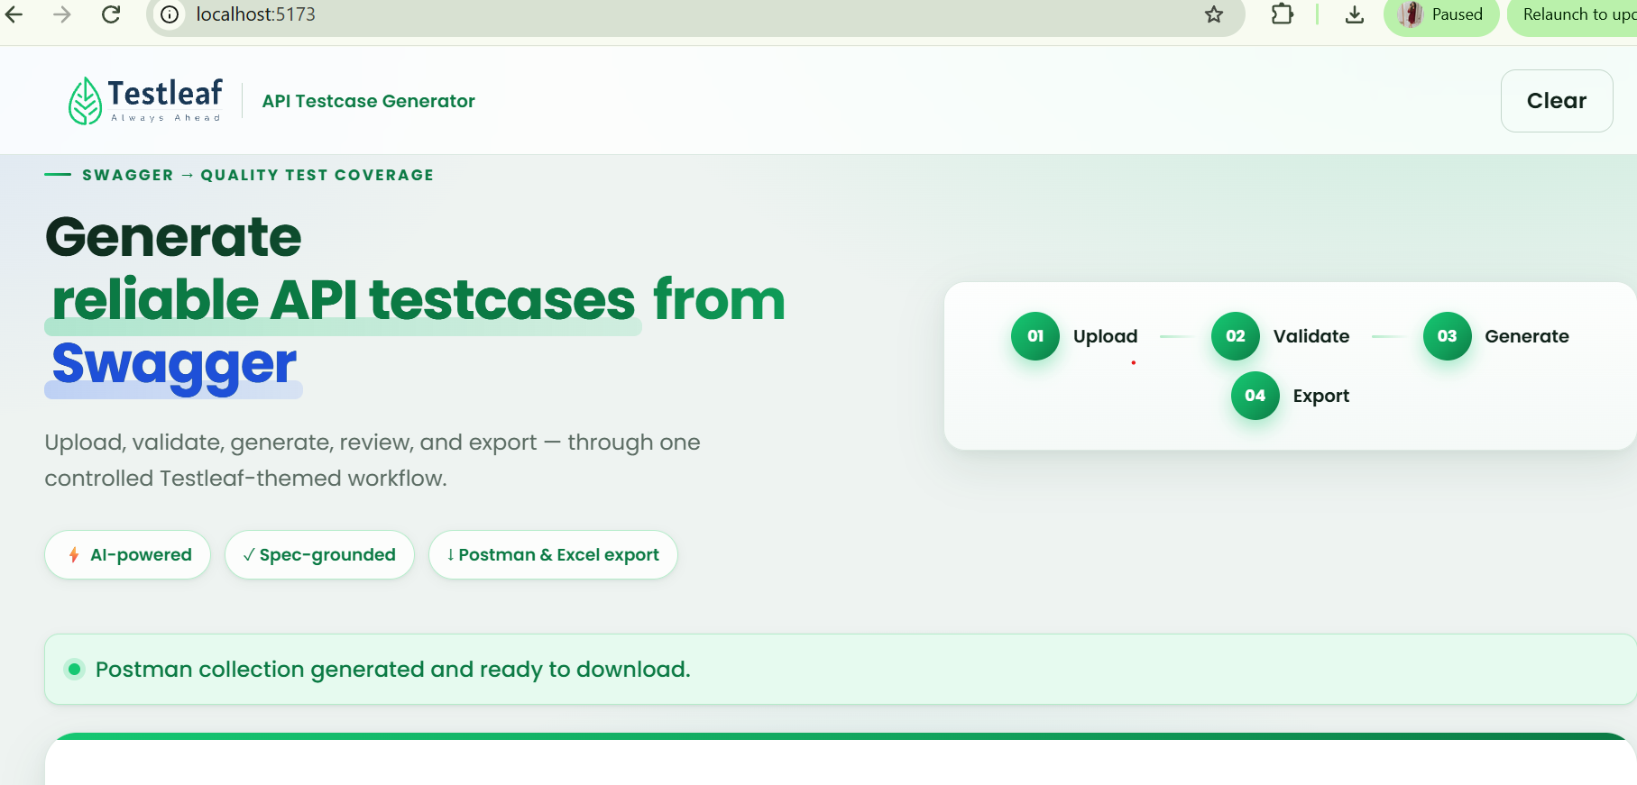

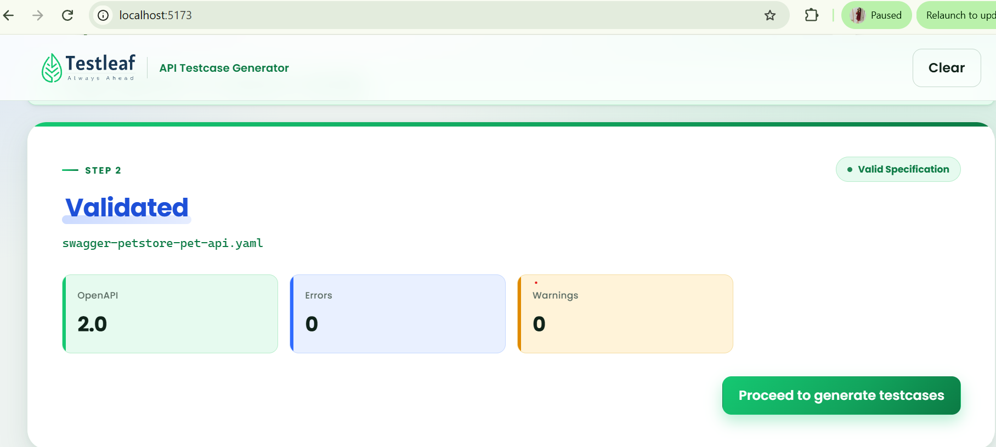

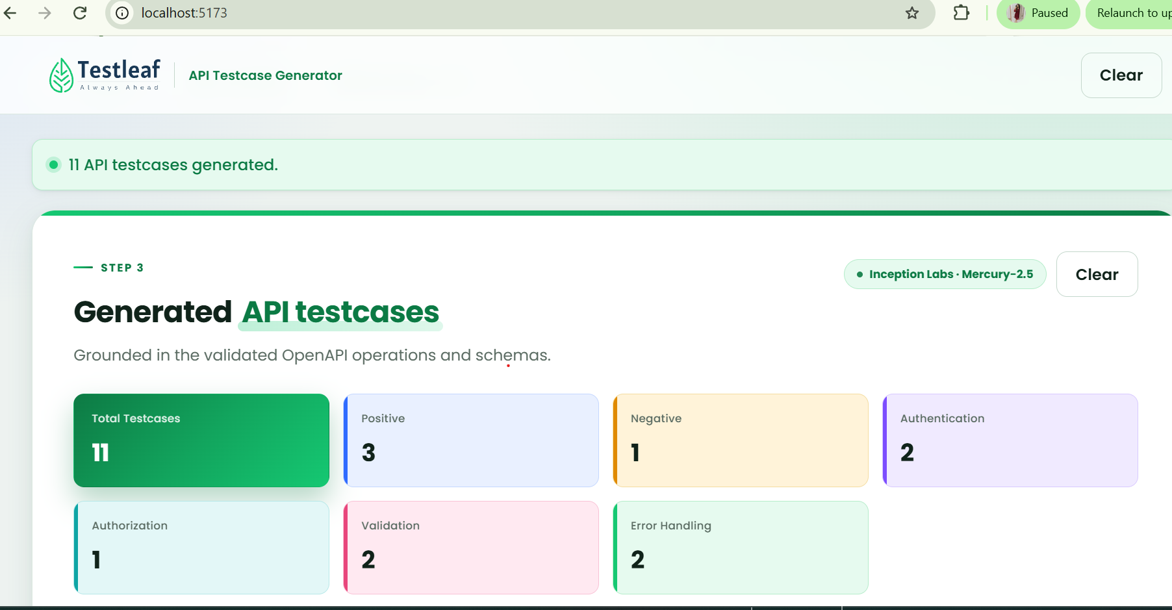

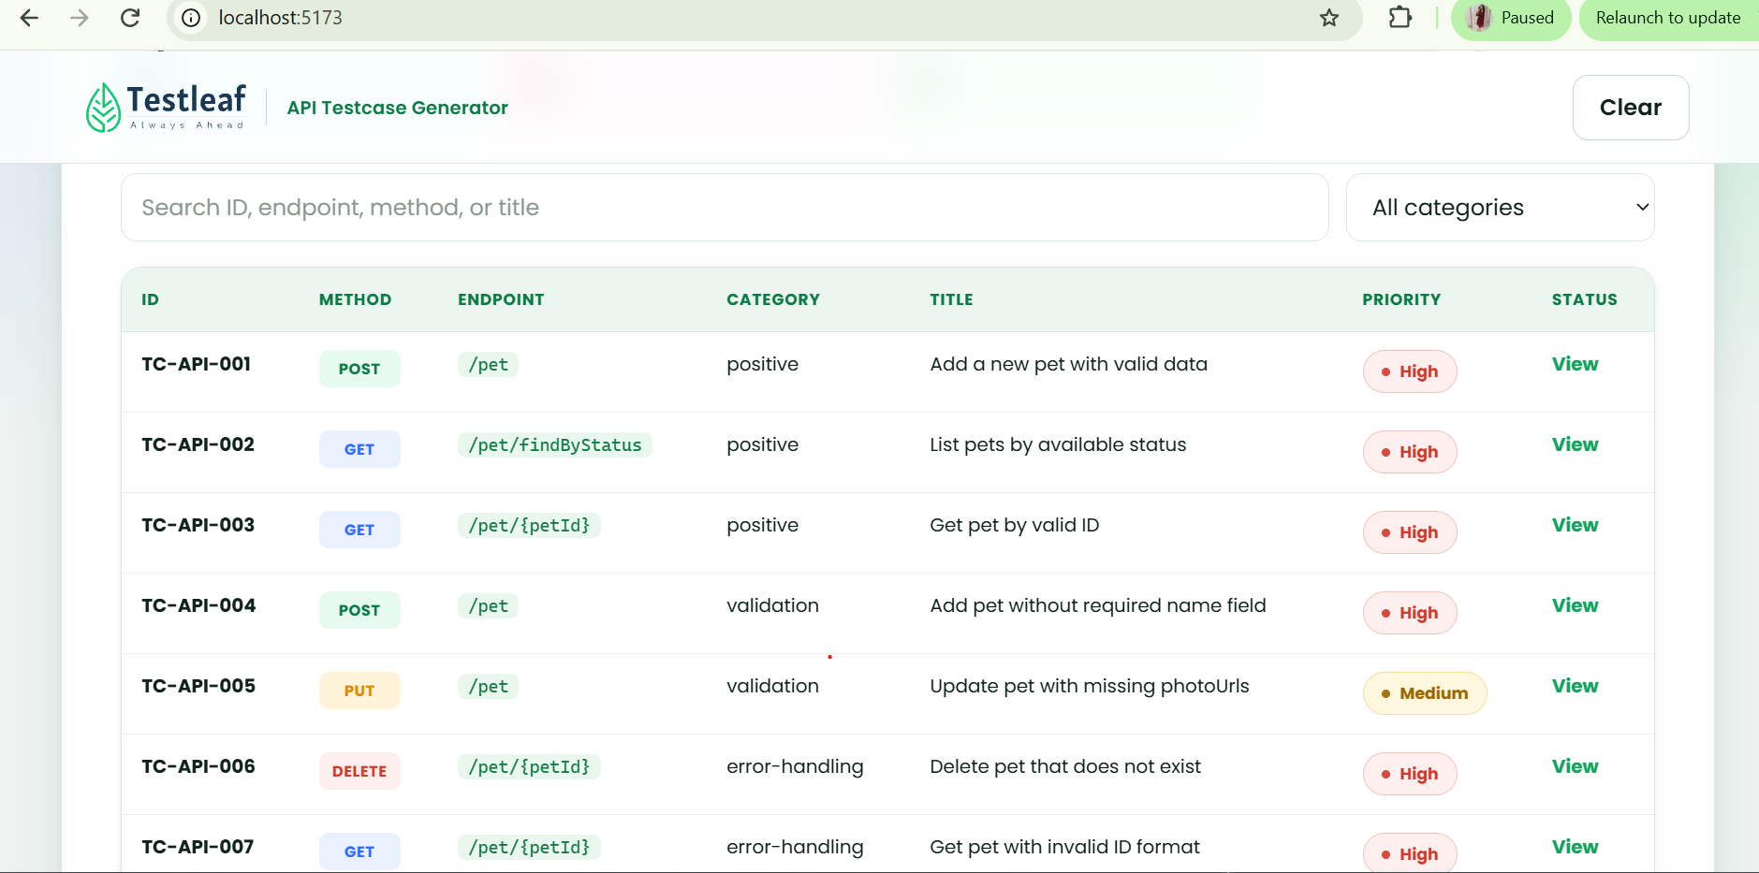

To create Radio buttons with link and upload options

ASK-
Analyze my entire project as an API Architect. Currently, after launching the agent, the application navigates directly to the upload file page. I want to introduce a new UI feature before this page by adding a radio button with two options: Upload File and Upload Link. The existing Upload File flow is already implementes and remain unchanged. If the user selects Upload Link, the application should accept a URL as input and generate test cases from thr content available at that link. Identify the impacted files. Do not implement any changes yet, only provide the list of impacted files. Once the analysis is complete , I will proceed with the implementation in agent mode.

